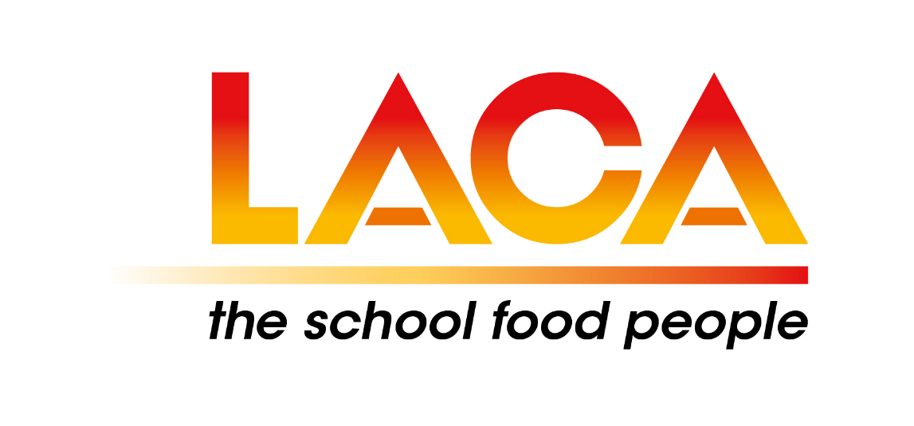

LACA East Midlands Regional Autumn Event
At Center Parcs
Rufford, Newark, Nottinghamshire NG22 9DN
On 2 October 2019
The heart of the catering industry joining together in the heart of Sherwood Forest

9.00am - Registration
9.30am - Stephen Forster, LACA Chair – LACA Update
10.00am - Regional Round Up
10.15am - Tess Kelly & Kate Snow – Food for the Future – Chef Manifesto in schools
11.00am - Center Parcs – Behind the Scenes!
11.30am - Meet the Suppliers
12.00pm - Lunch & Networking
1.00pm - Martin Kersh – Food Packaging Association
1.30pm - WRAP – Presenter to be confirmed
2.00pm - EHO Update – Presenter to be confirmed
2.30pm - Break
2.45pm - Joanne Campbell & Jessica Crane – Allergen Update
3.30pm - Charity Raffle & Event Closure



Click on the link to see a video of one of our Regional events
LACA - East Mids.mp4

For more information contact:
Kevin Hill
Kevin’s email is: kevin.hill10@virginmedia.com

PLEASE TICK THE FOLLOWING, WHERE APPLICABLE

Person’s attending the event ______________________

Cost per person £49.00

I enclose a cheque payable to LACA East Midlands Region to the value £________________

Please invoice me for £49.00 the purchase order number is _________________________

Name: __________________________________________

Email: ___________________________________________

Organisation: _____________________________________

Business Address: __________________________________

Post Code: _______________ Telephone: _______________

Dietary Requirement – please specify: ___________________________________________

__________________________________________________________________________

For office use: ________________ ________________ _________________

Please return this form to Kevin Hill, 14 Meadow Court, Broadmeadows, South Normanton DE55 3NG or kevin.hill10@virginmedia.com by 27th September 2019. (Early Bird nominations in by Monday 16th September 2019)
Venue: Center Parcs
Sherwood Forest, Rufford, Newark, Nottinghamshire NG22 9DN

Parking. Proceed to Arrivals Lodge. Park in Corporate Car Park (please take a note of your parking bay number). Follow signs to The Venue, walk past Guest Services, then turn left at Starbucks – walk is approx. 7 mins.

Raffle in aid of British Heart Foundation

