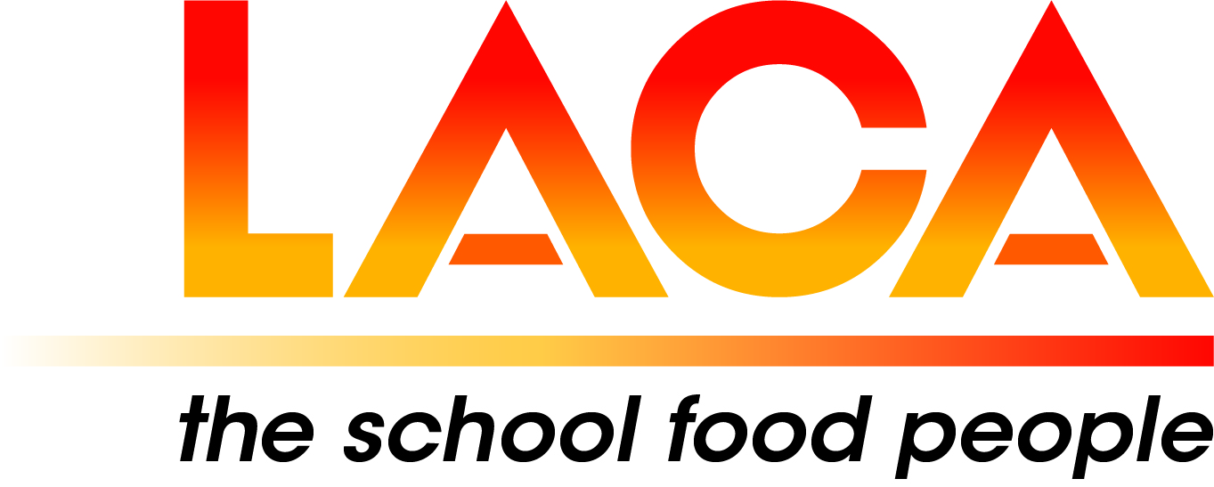

West Midlands Region

Annual General Meeting
Thursday 27 February 2025 via Microsoft Teams
Agenda

- Apologies

- Minutes of AGM on 8 February 2024.

- Matters Arising

- Committee 2024-2026

- LACA Board Report – Lorna Hicks

- Chair’s Report

- Treasurer’s Report

- Secretary’s Report

- Updates, pre-posted member items.

- Future Programme – Thursday, June 2025, via Microsoft Teams.

- Thursday, 16 October 2025, In-person.

- Your ideas for future programmes

