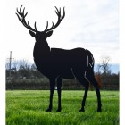
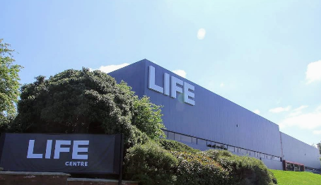

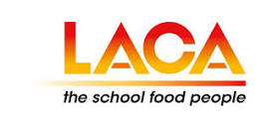
Wednesday 5th June 2024
Y&H LACA Regional Event

‘World of Procurement’

The Y&H Regional Committee would like to welcome you to join our rescheduled networking day, at LIFE Centre Events – Bradford. Providing an opportunity to hear industry experts discuss challenges and solutions, while facilitating the exchange of experiences, views and information sharing.
As caterers, manufacturers, producers and suppliers continue to navigate the ‘perfect storm’ around the procurement of sustainable food, there is a real need for public and private sector to collaborate to produce, procure and provide healthy, sustainable food, while keeping value within the local economy as much as possible.
Join our networking day to look at how effective procurement can provide sustainable solutions to help reduce food costs, while reducing our carbon footprint, as we all journey towards net zero targets.
We invite local businesses to share with us how they are promoting social sustainability, embedding fair trading practices across the food supply chain, bringing good working and living conditions for local farmers and producers who can sell locally for a fair price.
Learn of new and interesting sustainable food alternatives to help support caters and listen to the success of others and how they are addressing the on-going cost of living crisis.
We continue to maintain low prices for our events, enabling Education Catering service providers to attend and remain current with trends and market intel, including learning new initiatives, innovations and solutions. A great way to develop catering teams.
To maximise opportunities for Education Caterers, all our private & public sector catering providers are entitled to a ‘Buy one get One Free’ offer.
The event has moved more central, to once again support caterers experiencing travel restrictions attending events.
The venue - LIFE Centre Events is a charity/social enterprise. This means that the proceeds of your booking go towards their social project for the benefit of Bradford Communities.

Charity Support
The children’s charity we will be supporting on the day will be the children’s community hub at the life centre, which will once again help local children’s community.

World Of Procurement Itinerary
08.30 | Registration: Refreshments, Networking & Raffle Support | Mins
09.15 | Welcome from Jo Webster & Damien O’Brien – Itinerary & Supported Charity | 10
09.25 | Pelican – Sustainable Procurement | 20
09.45 | Dancing Goat Coffee – Supplier Showcase – Sustainable Coffee | 10
09.55 | Bob Snail – Supplier Showcase | 10
10.05 | Brakes – Contract Challenges & Considerations | 20
10.25 | Highland Game – Venison – A Great Alternative | 20
10.45 | Coffee Break & Networking – Raffle Support | 30
11.15 | Green Cuisine – Supplier Showcase | 10
11.25 | Michael Hales – View from the Bridge | 20
11.45 | Fix Our Food – Yorkshire – Sustainable Procurement of Food | 20
12.05 | YPO – Procurement Reform | 15
12.20 | Turner Price – Sustainability, Brands & alternatives. | 15
12.35 | Lunch, Networking & Sampling | 40
13.15 | Foodie Quiz – A Test for the tastebuds ! | 30
13.45 | Gazegill Organics – A farming family | 20
14.05 | The Organic Pantry – An organic local solution | 20
14.25 | Quiz Results – Raffle Draw | 20
14.55 | Thank You & Close | 5
15.00 | Finish – Safe Journey Home

Admission £25+Vat PP – Members - £30 +Vat PP Non-Members
LIFE Centre Events
Wapping Road
Bradford
BD3 0EQ

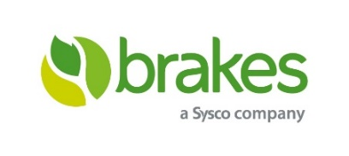
Sponsoring Suppliers & Presenters:



