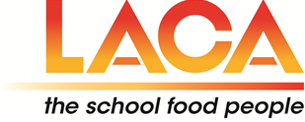

LACA NORTH EAST & SCOTLAND

AUTUMN SEMINAR & FINISHING TOUCHES COMPETITION 2019

BOOKING FORM
PLEASE NOTE THERE IS NO CHARGE FOR THIS EVENT
NAME OF ATTENDEE | AUTHORITY/ORGANISATION

IF YOU ARE A FINISHING TOUCHES COMPETITOR AND WISH TO
ATTEND THE SEMINAR, PLEASE ALSO COMPLETE A BOOKING FORM

PLEASE FORWARD YOUR COMPLETED BOOKING FORM TO: -
anita.brown@stockton.gov.uk BY FRIDAY 1st NOVEMBER, 2019

