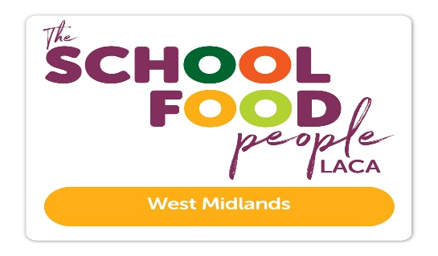

Date: 4 May 2026
Ref: LACA/KIH
Email: kathleen.hayton@ntlworld.com
Mobile: 07831 693385

Dear Member,

Regional Event on 4 June 2026 at 1.30pm via Microsoft Teams

I refer to my email on 5 January 2026 advising diary dates for Regional Meetings 2026 and now confirm the programme and booking details for the online Meeting on Thursday 4 June 2026 at 1.30pm via Microsoft Teams.

Programme
1.30pm Welcome – Lorna Hicks, Chair

1.40pm TSFP Update – Brad Pearce, National Chair.

2.10pm NSPCC Number Day 2027 – an annual maths inspired school and nursery fundraising event -
Stephanie Coleman, Senior School Fundraiser, NSPCC.

2.30pm SCOTY 2026 West Midlands Regional Winner – The SCOTY experience – Nicolas Poilblanc supported by
Andrew Padfield, Regional Development Chef, Aspens Services Ltd. St Peters Collegiate Academy, Wolverhampton.

2.40pm SCOTY 2025 – From Wildcard to National Winner – Erin Ward, Impact Food Group, Holmer Green School will tell us about all the exciting Events and opportunities she has enjoyed since July 2025.

3.00pm Political update following May Local Elections – Lee Petar, Managing Partner, Menara Advisors

3.20pm Questions and close.

To book a place, please email me, not later than Friday 15 May 2026. Please include your name, Local Authority/School/Company and email address.

Email: kathleen.hayton@ntlworld.com. Lorna will send the Meeting Link a few days before the Meeting.

Diary date – Please note change of date. Now, Thursday 8 October 2026
Joint East & West Midlands Regional All-Day Event at Parts Town UK, Cannock, new Conference Suite.

I look forward to seeing you online on 4 June 2026, and especially welcome new Members.

Yours sincerely
Kath Hayton
Hon. Secretary

