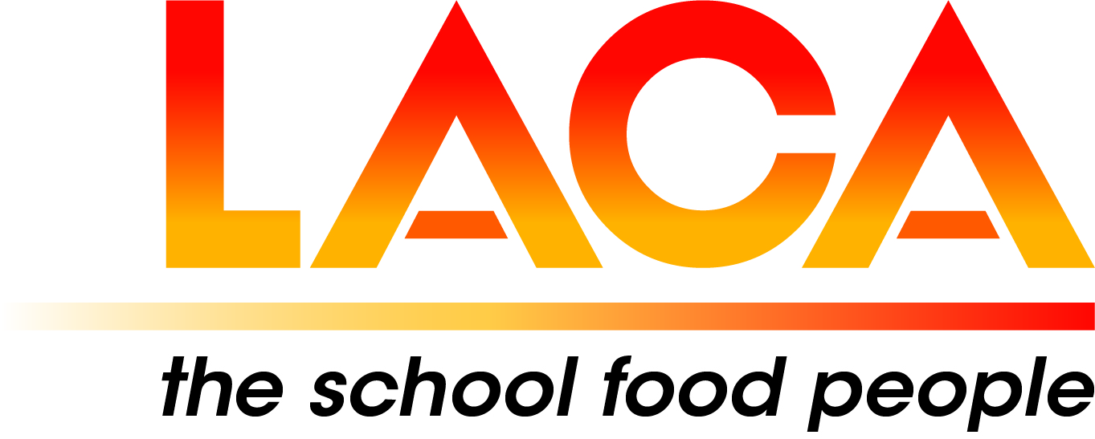

Date: 24 January 2025
Ref: LACA/KIH
Email: kathleen.hayton@ntlworld.com
Mobile: 07831 693385

West Midlands Region

Dear Member,

Regional Meeting & AGM on Thursday 27 February 2025 at 1.30pm via Microsoft Teams

I refer to my email dated 14 January 2025 and now confirm the programme and booking details for the online Meeting on Thursday 27 February 2025 at 1.30pm via Microsoft Teams.

Programme
1.30pm Welcome – Lorna Hicks, Chair

1.40pm AGM – Agenda attached. If you wish to post any items for the agenda and/or have ideas for future programme/venues, please email me.

2.00pm ‘Food for Life Served Here’ - Sophie Pritchard, Head of Sustainable Catering, Soil Association

2.20pm LACA National Update - Judith Gregory, LACA National Chair. Judith will update members on LACA's campaign for fairer school meals funding and share the plans for 2025.

3.00pm ‘Technology in the Kitchen - Solihull Catering Services experience’ - Paul Wayman, Head of Catering Services, Solihull MBC.

3.20pm ‘My life at Hollinswood School’ - Kathy Dennis, Veteran Chef, Hollinswood Primary School, Telford & Wrekin Council.

3.40pm Questions

4.00pm Close.

To book a place, please email Jayne Hill, not later than Friday 7 February 2025. Please include your name, Local Authority/School/Company, email address and contact details.

Email: jhill@whmat.academy. Lorna will send the Meeting Link a few days before the Meeting..

I look forward to seeing you online on 27 February 2025, and especially welcome new Members.

Diary Date: Regional Meeting online on Thursday 5 June 2025 at 1.30pm via Microsoft Teams

Yours sincerely

Kath Hayton
Kath Hayton
Hon. Secretary

