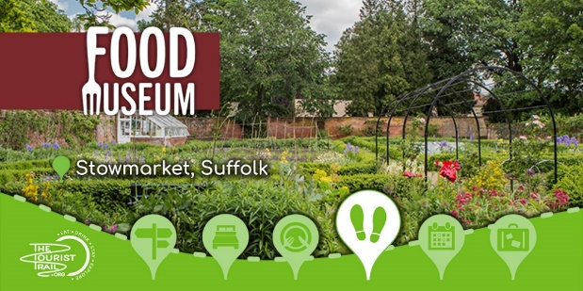
East of England Regional Event and AGM
The Food Museum, Stowmarket
9.30am-3pm,
Thursday 5 th June 2025

Agenda
Welcome and National Update from National Vice Chair Micheal Hales
Allergen Challenges Presented by Mike Travis, School Grid
Daily operational challenges faced by our catering team Presented by Tom Frost Aspens
Balancing Nutrition and Budget Presented by John Want HCL
SCOTY – Q&A with Carol Harwood LACA Lead for Scoty joined by our regional competitors
Plus a Tour of School Food exhibition

During the day there will be the opportunity to network and chat to our supporting suppliers.

Refreshments and Lunch will be provided along with charity raffle

We look forward to welcoming you all on the day

